#TinyHouse comes to South Jersey
Shannon Eblen, @CP_ShannonEblen4:23 p.m. EST November 4, 2015
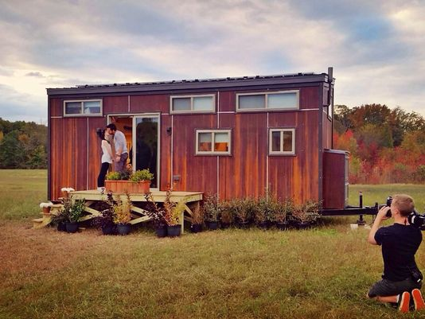
(Photo: Vincent Sorgentoni)
In New Jersey, it has been slow to catch on. With television shows like “Tiny House Nation” and the upcoming “Tiny House World,” and the dozens of social-media pages devoted to tiny-house living, one might think the movement is sweeping the country.
“There is zero support for tiny homes in South Jersey,” said Vincent Sorgentoni, who lived in a tiny house in Mickleton with his girlfriend, Sam Adams, for just under a year. They recently sold the house, as their commute to Philadelphia for work and school was difficult, and they couldn’t find a place to put the house in the city.
Sorgentoni doesn’t know any other local tiny-house enthusiasts. “We’re pretty much it,” he said.
Yet there are a lot of reasons people want to live small, and those who are starting the process, or have been through it, like Sorgentoni, can offer advice to those wanting to become tiny-home dwellers.
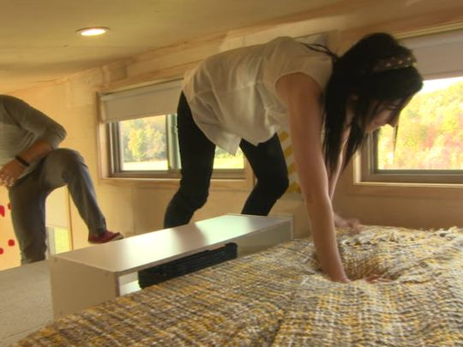
Vincent Sorgentoni and Sam Adams climb into the loft in their tiny house. (Photo: Vincent Sorgentoni)
Andria Fort, of Oakhurst, Monmouth County, has many reasons for wanting to move into a tiny house. She wants to be able to travel, and not have so much invested in her house.
“I really just want to live more simply,” Fort said. “I just don’t want to have the ties to a house."
She wants to be an example for her children, she said, that one doesn’t need a mansion to be happy.
“I don’t see any reason not to go smaller,” she said. “I’ve decided that less is more.”
Tiny homes are innovative; with so little space, it is a necessity. There also is the environmental footprint, or lack thereof, of a tiny house. Many homes have environmentally friendly features, such as Sorgentoni’s did.
The kitchen in Vincent Sorgentoni's tiny house. (Photo: Vincent Sorgentoni)
“It was completely solar-powered, so we were off the electrical grid,” Sorgentoni said. “It had a compost toilet. It was very green … that was a big part of why we did it, not the financial implications.”
Sorgentoni's home was featured in an episode of "Tiny House Nation,'' which showed it being built.
“It was so personal and customized,” Sorgentoni said of the house, which he designed with Wishbone Tiny Homes of Asheville, North Carolina. “It has to be designed by you, nobody else can do it.”
In terms of the finances, Sorgentoni doesn’t think they saved a lot of money while they were living in the tiny house, as they owned the house, but still had to rent the land it was on.
“Part of the problem here is,” Fort said, “if people want to say in New Jersey, your land is going to cost more than your home.”
Fort said in her research, she has found few places offering financing options for the home itself. Rather than having a mortgage, she would need most of the money up-front.
“In terms of price in comparison with a normal house, your up-front cost is a lot less,” said James Stoltzfus, the owner of Liberation Tiny Homes in Lancaster, Pennsylvania. “But I think the most important part to people is your day-to-day expenses are very little.”
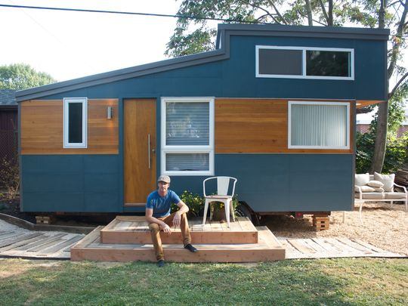
James Stoltzfus, owner of Liberation Tiny Homes, in front of a house he designed. (Photo: Liberation Tiny Homes)
Stoltzfus has only recently started his business designing and building tiny homes. His complete-package tiny home is $37,500, according to his website, much less than a traditional house costs.
Utilities, he said, also go down because of the house size. “The price of living really drops significantly,” he said.
One tricky thing about having a tiny house is having a place to put it.
The regulation of tiny houses varies by municipality, but Sorgentoni said in their area of South Jersey, there were no laws prohibiting a tiny house.
While "Tiny House Nation" was filming, a neighbor did complain about the structure. The owners couldn’t be fined, though, because the house was registered as a vehicle, through the Department of Motor Vehicles.
“And that’s why a lot of people put them on wheels,” Sorgentoni said. “Technically, you can put it anywhere you would park a vehicle.”
New Jersey law restricts mobile homes to a height of 13 feet, 6 inches. Sorgentoni’s was 13 feet, 5 inches.
However, tiny houses aren’t quite like RVs. When people think of tiny homes, Sorgentoni said, they think of a trailer park.
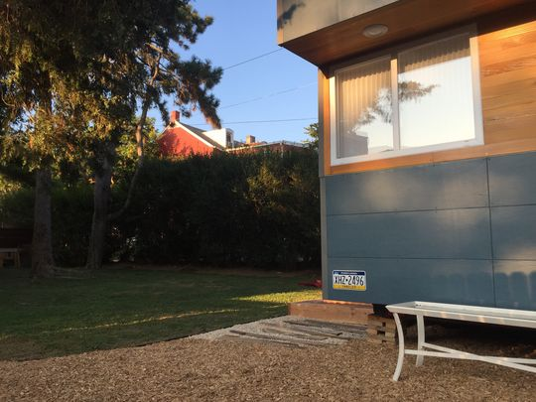
Many tiny homes actually meet the legal description of a mobile home, and are registered with the local Department of Motor Vehicles. (Photo: Liberation Tiny Homes)
“It was a luxury home,” Sorgentoni said. “It was just 200 square feet.”
Fort wants her eventual house to only be about 150 square feet. And that calls for serious downsizing.
“You begin with the big things,” Fort said of the process of purging her belongings. “Non-sentimental items first.”
The family heirlooms are the biggest challenge, old family photos and antique furniture. “I’ve been the keeper of everyone’s memories for years,” she said.
It's a common challenge for people going the tiny-house route.
“I have a boatload of stuff, I have a lot of hobbies,” Sorgentoni said. “I had to downsize a lot.”
Sorgentoni kept belongings in a storage unit, but he and Adams also managed to fit a lot of stuff in their house. One of his strategies was making sure everything in the house had at least two functions. Most often, that meant hidden storage.
“It wasn’t that big of a compromise,” he said. “I didn’t want it, but we had a microwave, and three different ways to brew coffee in the morning. We had every creature comfort.”
The space-saving techniques take a lot of thought, Stoltzfus said.
“I just did a ton of research on what it means … to make the most of each space,” he said. “For example: fold-down work areas and tables. Putting compartments in walls. My couch is a bed and there is also storage on one side of it. The stairs leading to the loft, a lot of people build cabinets underneath.”
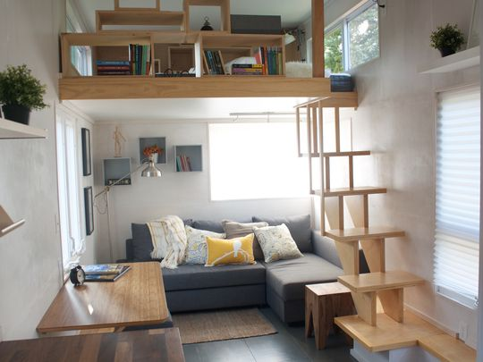
The interior of a house from Liberation Tiny Homes, designed by James Stoltzfus. (Photo: Liberation Tiny Homes)
Stoltzfus doesn’t live in a tiny house, though he hasn’t ruled it out.
“I really liked the lifestyle and the whole philosophy,” he said. “I thought it would be fun to build one and see what happens.”
Fort is waiting for her son, who just finished high school, to move out before she makes the move to a smaller home. And while tiny homes seem to suit millennials, such as Sorgentoni, particularly well, Stoltzfus said he has met tiny-home clients ranging from their 30s to their 60s.
“It wasn’t mainstream two years ago,” he said. “The TV shows started coming out and that created a whole new audience.
“I think it definitely hit mainstream.”
Shannon Eblen: SEblen@gannettnj.com or (856) 486-2475
MORE INFORMATION
For more on Liberation Tiny Homes, call (717) 371-8242 or visit liberationtinyhomes.com/
Nancy Underwood, a professional organizer who owns Organized for Life, offered some tips for people looking to declutter and downsize.
- "Give yourself as much lead time as possible. People think it doesn't take as long as it does."
- Know your space: Measure your new home, have photos, have a floor plan and start sketching where things will go.
- "Count your kitchen and bath cabinets and only keep what might fit within them."
- Look at pieces for utility and value. Ask yourself, when was the last time you used it, and does it have a place in the new house. "People aren't sure what they want, so they err on the side of bringing it with them."
- When getting rid of things, start with the large pieces.
- You might not be able to keep as much as you think: "Whatever you think it going to fit, I would reduce that by a quarter to a third."
- Avoid storage units; they are counterproductive to the decluttering process. "A lot of times, it's delaying decisions."
- "Get help." Either seek help from a professional, or family and friends who understand your needs and goals during the decluttering process.
For more information, or to contact Nancy, call (856) 371-8784 or visit organizedforlifenu.com/

